Assignment 17.3

Write a mapreduce job that takes configuration from command line (min.word.count). Based on the configuration, it should perform count of words from a document and produce only those words in the output whose count is greater than or equal to the configuration.

Input file

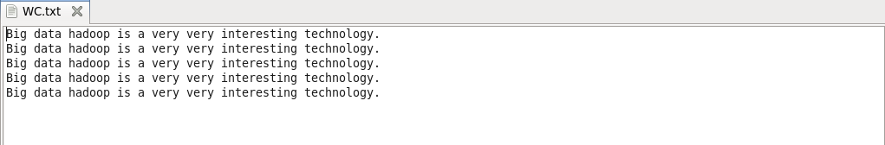

Driver class

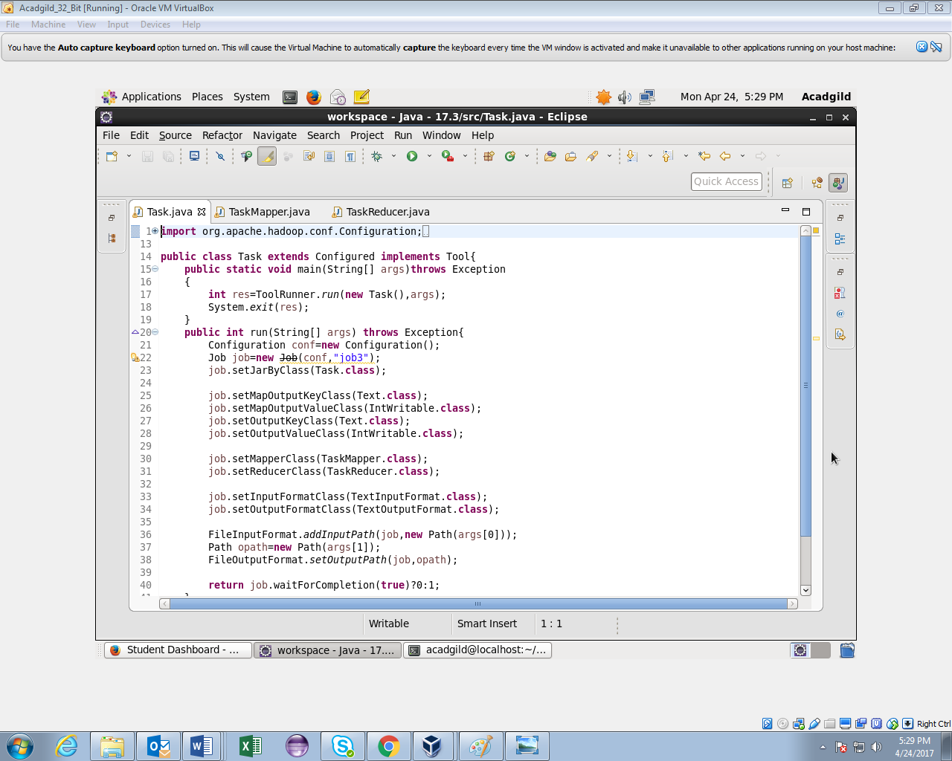

Mapper class

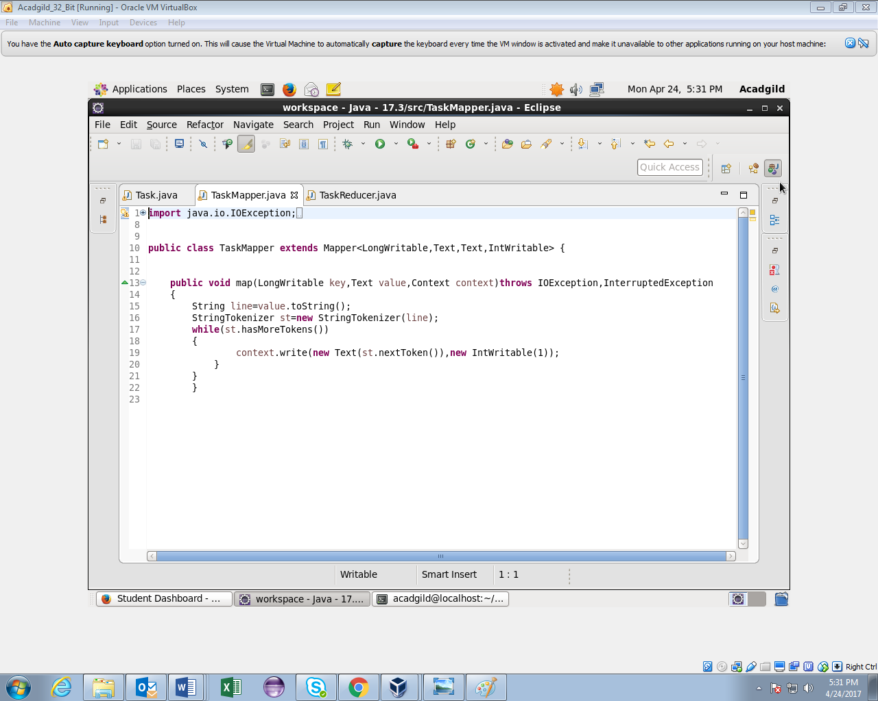

Reducer class

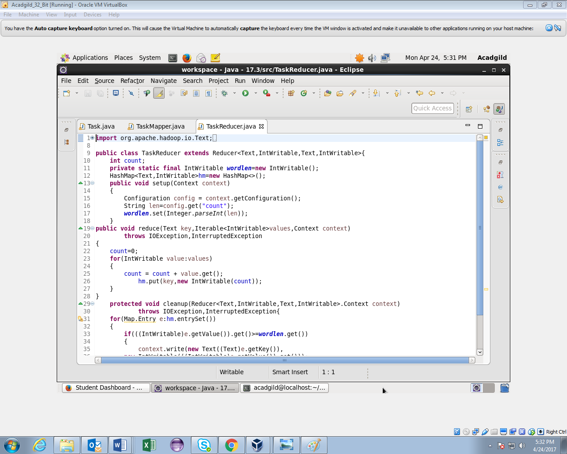

Reducer class(contd..)

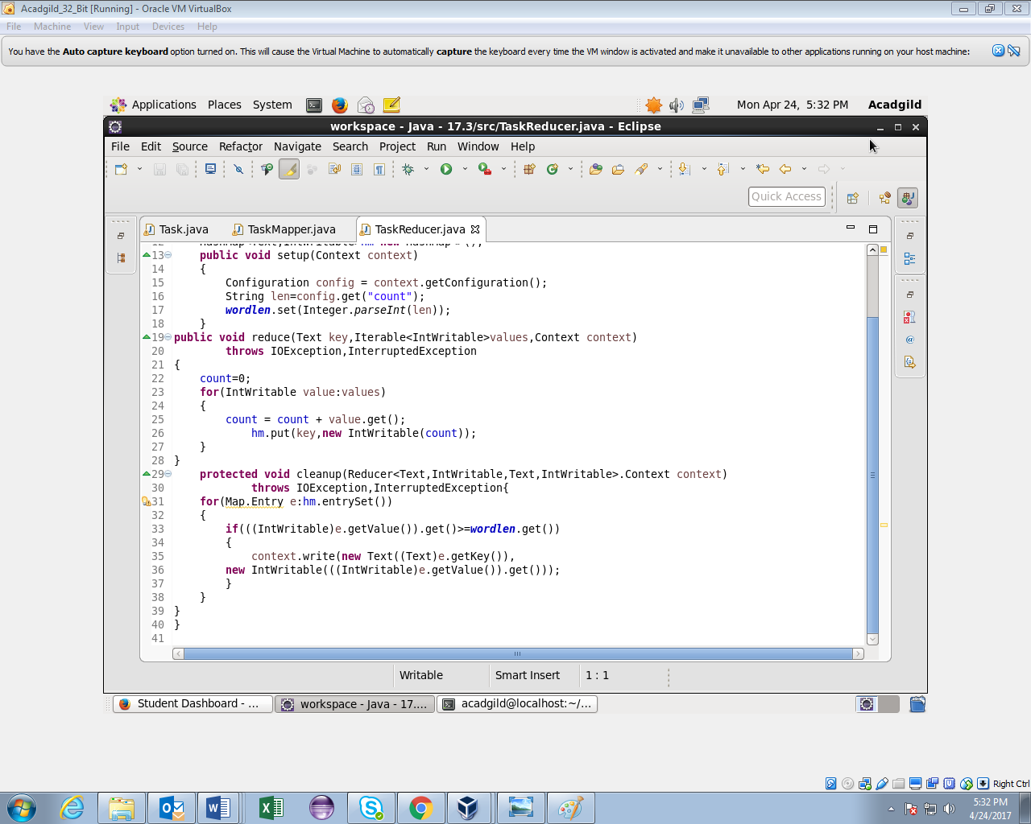

Output

